**PYTHON CODES FOR REAL TIME USE CASES**

**Case Study 1 :** **Automated Vending Machine Simulation**

**Objective:** Design a Python program to simulate a basic automated vending machine. The machine will dispense items based on user inputs, and the program will use for and while loops, along with break and continue statements, to control the flow of the vending process.

**Scenario:** You are tasked with programming an automated vending machine.

The machine sells three items:

1. Item A - Price: $2

2. Item B - Price: $3

3. Item C - Price: $5

The vending machine will:

1. Display the available items to the user.

2. Accept the user's selection and the amount of money they insert.

3. Dispense the item if the user inserts enough money.

4. Return the change if any.

5. If the user inserts insufficient money, prompt them to either insert more money or cancel the transaction.

6. Allow the user to exit the vending machine at any point by typing "exit."

Solution :

CODE – 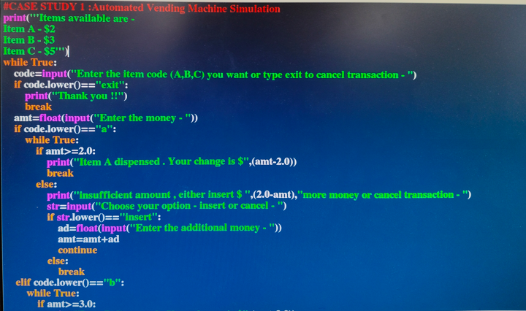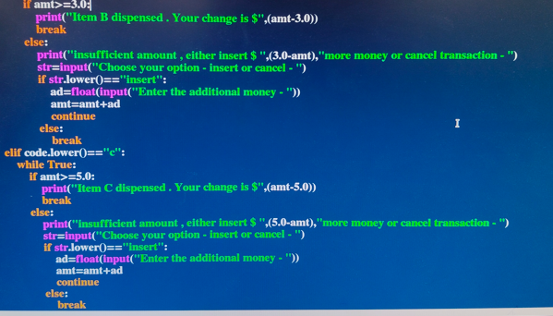

OUTPUT –

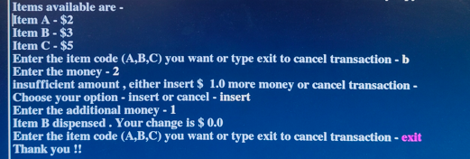

**Case Study 2** : : **Simple ATM Machine Simulation**

**Objective:** Design a Python program to simulate a basic ATM machine. The program will allow users to perform transactions such as checking the balance, withdrawing money, and depositing money. The program will utilize for and while loops, along with break and continue statements, to control the transaction flow.

**Scenario:** You are tasked with programming a simple ATM machine.

The ATM will allow the user to:

1. Check their account balance.

2. Withdraw money from their account.

3. Deposit money into their account.

4. Exit the ATM system.

The ATM will:

1. Start with an initial balance of $500.

2. Allow the user to select an option from a menu of available actions.

3. Process the user's selection and execute the corresponding transaction.

4. Repeat the process until the user decides to exit the ATM by selecting the appropriate option.

Solution :

CODE –

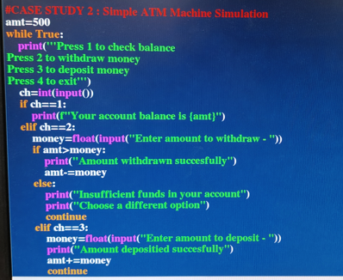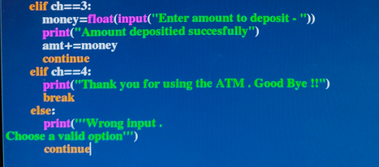

OUTPUT –

